**NAME**: RAJA SHEREEP M

**YEAR OF STUDYING**: III YEAR

**GIT REPOSITORY**: <https://github.com/Raja-shereep/project.git>

**INTERNSHIP**: **Microsoft Azure Fundamentals at PINESPHERE**

From 06/08/2024 To 10/08/2024

Working in Microsoft Azure :

Contents:

1. Creation of virtual machine.
2. Deploying git repository in VM.
3. Creation of Storage account(Blob creation).
4. Creation of static web apps to deploy git repository.
5. Creation of virtual machine:

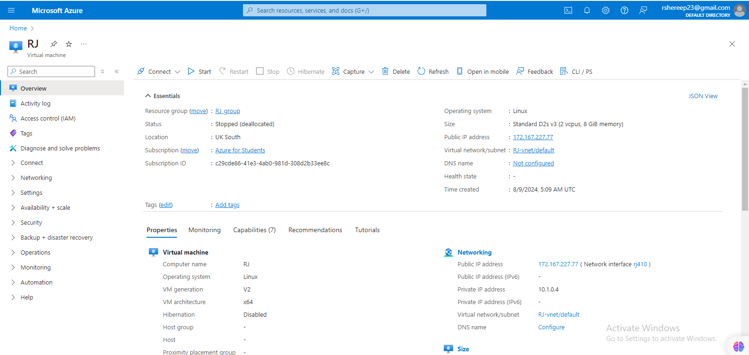

1. Deploying git repository in VM:

RJ@RJ:~$ sudo apt update

Hit:1 http://azure.archive.ubuntu.com/ubuntu noble InRelease

Hit:2 http://azure.archive.ubuntu.com/ubuntu noble-updates InRelease

Hit:3 http://azure.archive.ubuntu.com/ubuntu noble-backports InRelease

Hit:4 http://azure.archive.ubuntu.com/ubuntu noble-security InRelease

Reading package lists... Done

Building dependency tree... Done

Reading state information... Done

4 packages can be upgraded. Run 'apt list --upgradable' to see them.

RJ@RJ:~$ sudo apt install git

Reading package lists... Done

Building dependency tree... Done

Reading state information... Done

git is already the newest version (1:2.43.0-1ubuntu7.1).

0 upgraded, 0 newly installed, 0 to remove and 4 not upgraded.

RJ@RJ:~$ sudo apt install nginx

Reading package lists... Done

Building dependency tree... Done

Reading state information... Done

nginx is already the newest version (1.24.0-2ubuntu7).

0 upgraded, 0 newly installed, 0 to remove and 4 not upgraded.

RJ@RJ:~$ sudo systemctl start nginx

RJ@RJ:~$ sudo systemctl enable nginx

Synchronizing state of nginx.service with SysV service script with /usr/lib/systemd/systemd-sysv-install.

Executing: /usr/lib/systemd/systemd-sysv-install enable nginx

RJ@RJ:~$ cd /var/www/html

-bash: cd: /var/www/html: No such file or directory

RJ@RJ:~$ sudo mkdir -p /var/www/html

RJ@RJ:~$ sudo chown -R www-data:www-data /var/www/html

sudo chmod -R 755 /var/www/html

RJ@RJ:~$ ls -la /var/www/html

total 8

drwxr-xr-x 2 www-data www-data 4096 Aug 9 07:32 .

drwxr-xr-x 3 root root 4096 Aug 9 07:32 ..

RJ@RJ:~$ cd /var/www/html

RJ@RJ:/var/www/html$ ls

RJ@RJ:/var/www/html$ sudo rm -rf *

RJ@RJ:/var/www/html$ sudo git clone https://github.com/Raja-shereep/project.git .

Cloning into '.'...

remote: Enumerating objects: 27, done.

remote: Counting objects: 100% (27/27), done.

remote: Compressing objects: 100% (25/25), done.

remote: Total 27 (delta 6), reused 0 (delta 0), pack-reused 0

Receiving objects: 100% (27/27), 1.24 MiB | 45.25 MiB/s, done.

Resolving deltas: 100% (6/6), done.

RJ@RJ:/var/www/html$ sudo chown -R www-data:www-data /var/www/html

**output:**



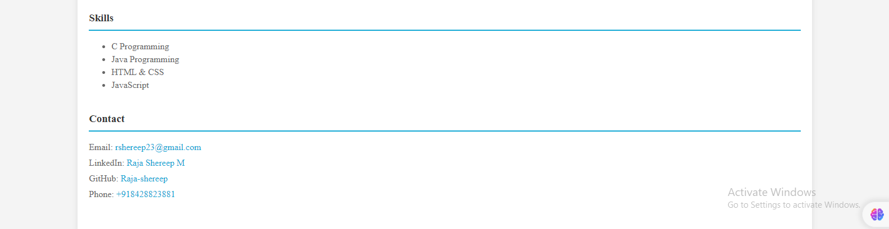

1. Creation of Storage account (Blob creation).

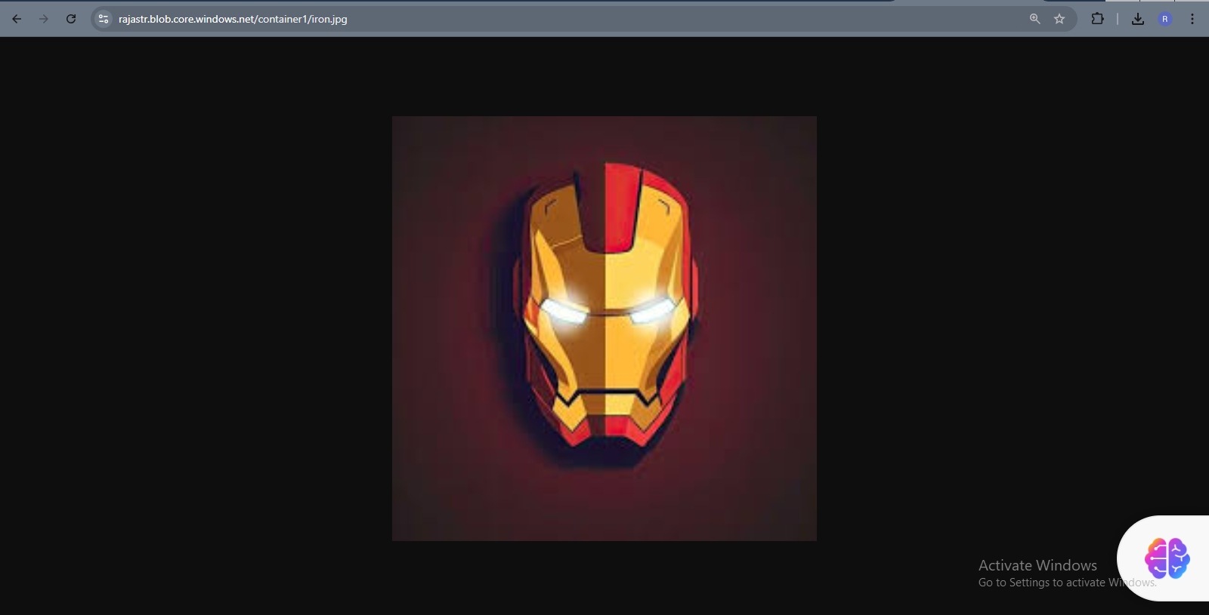

<https://rajastr.blob.core.windows.net/container1/iron.jpg> .

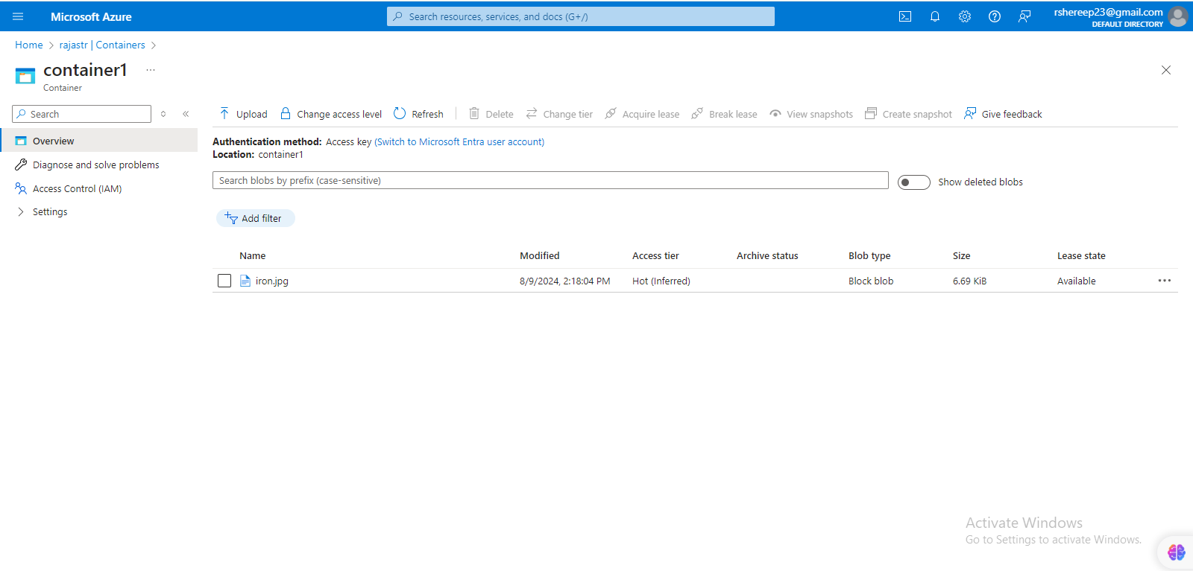

1. Creation of static web apps to deploy git repository:

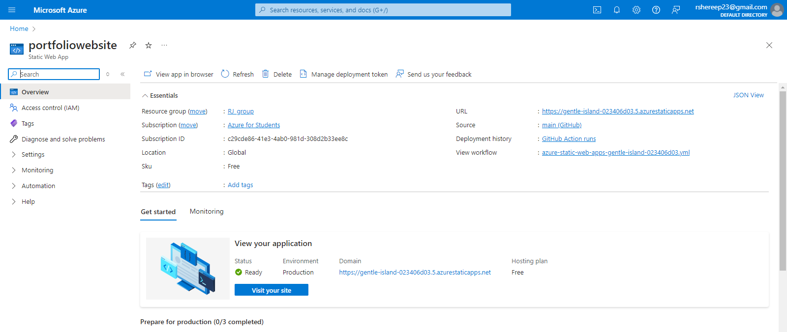

[https://gentle-island-023406d03.5.azurestaticapps.net](https://gentle-island-023406d03.5.azurestaticapps.net/)



